# User Manual For guest user and customers

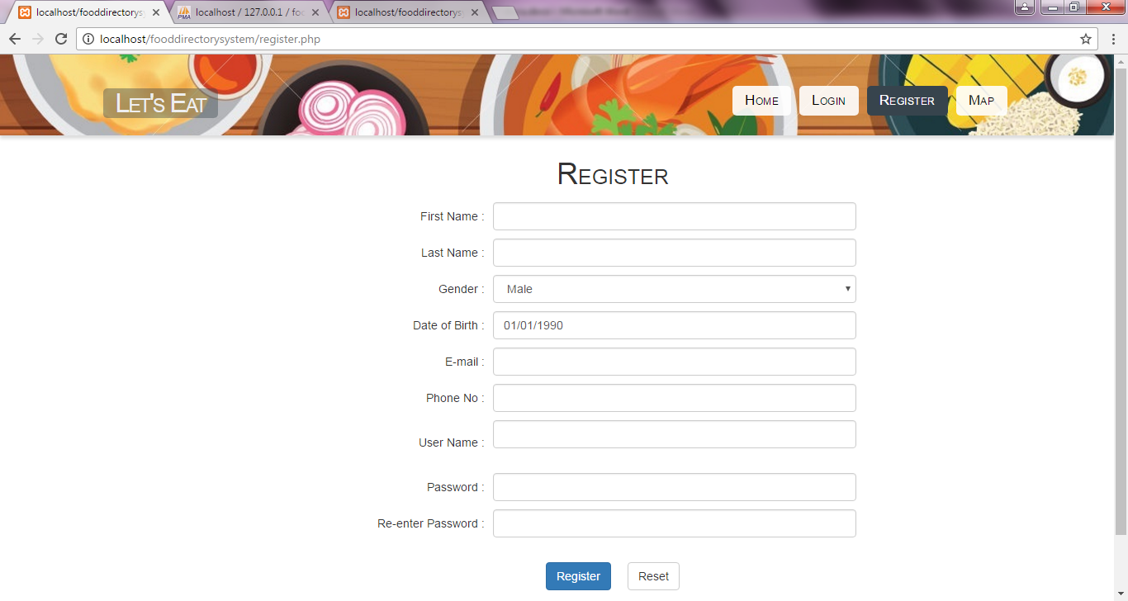

This is the registration page. In this page the users would be able to register by filling the deailed information about themselves.

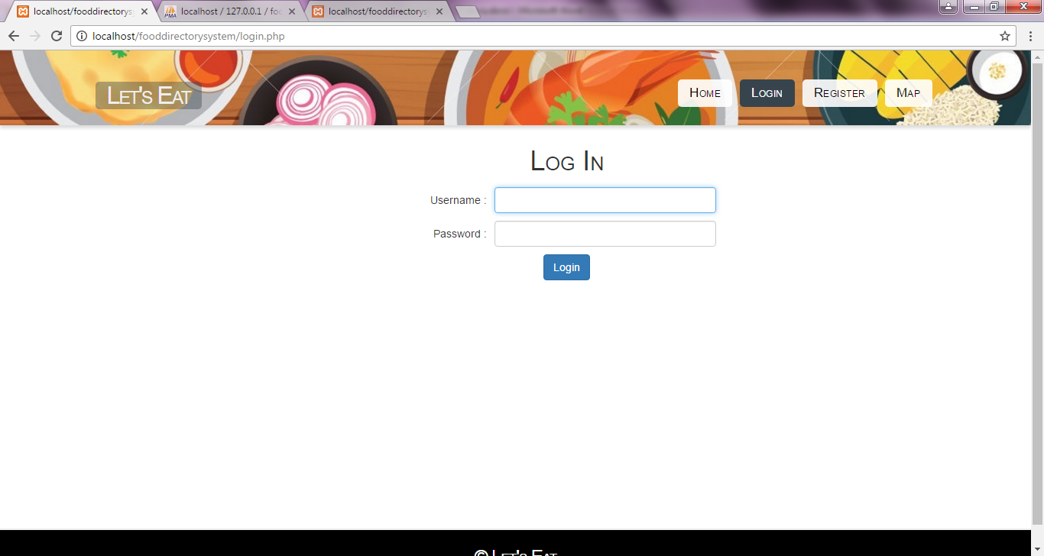

This is the log in page. After regtration process, the user can have access by logging in to the system from this page.

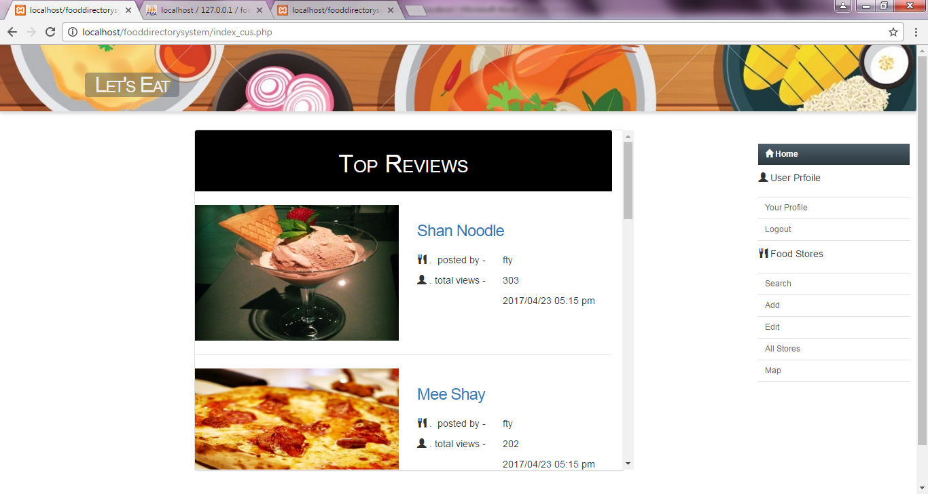

This is the home page. The customers can view the review detail by clicking on the blue link. The reviews are stored by the number of view counts.

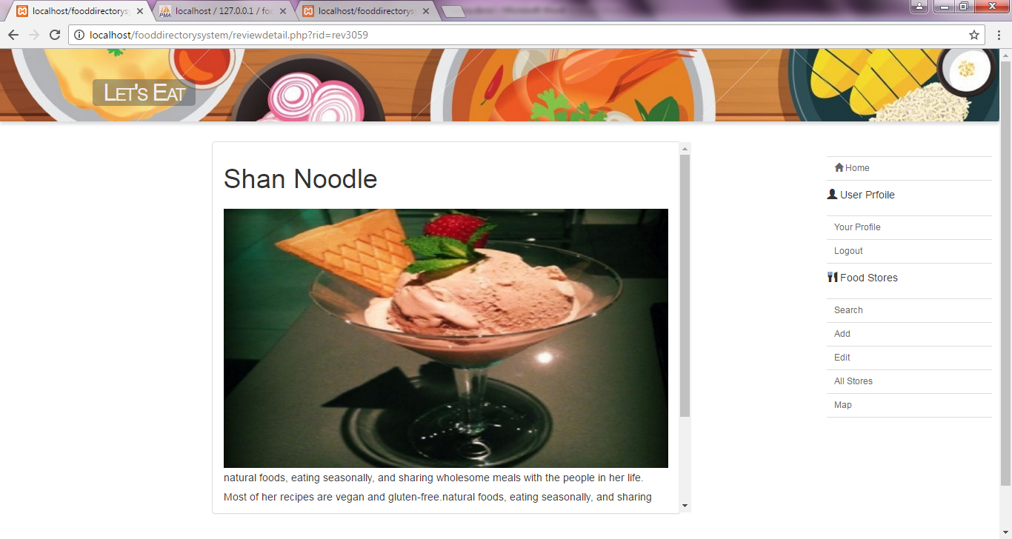

This is the review detail page.

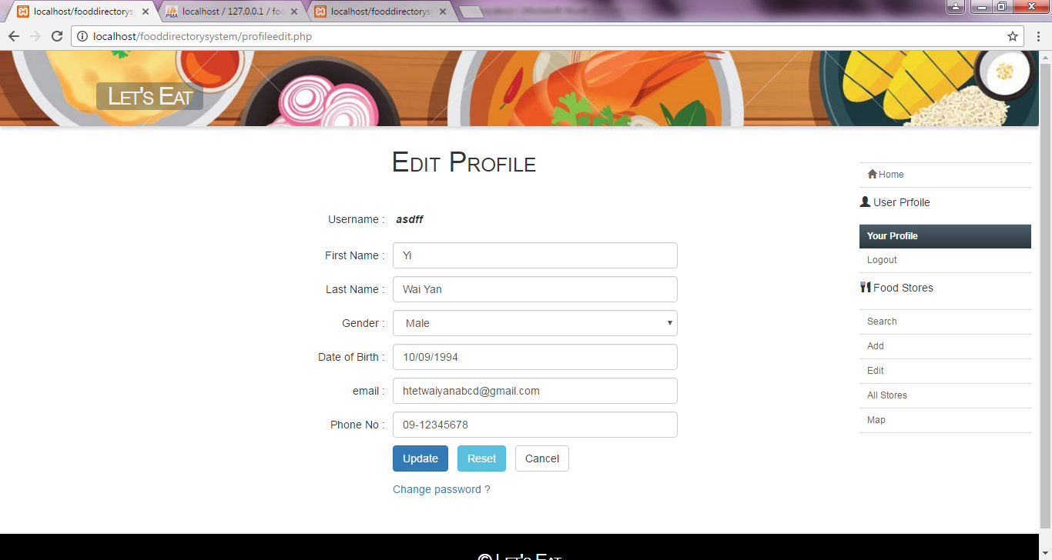

This is the ‘your profile’ page. In this page, the customers can be able to change the detailed information and the password.

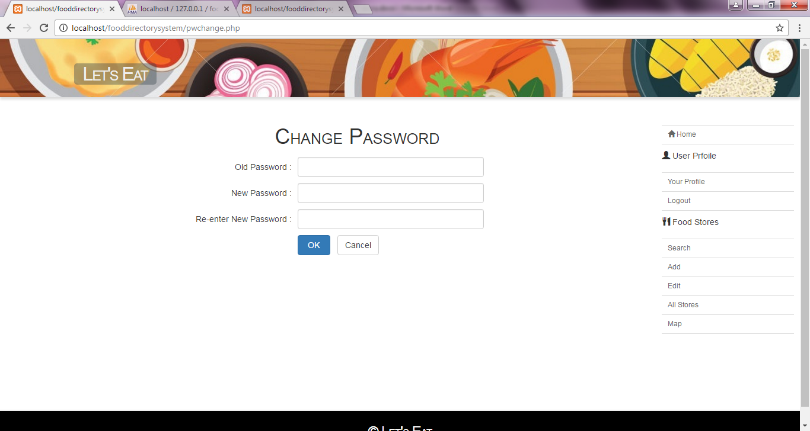

This is the change password page. This page will appear when the user click on the ‘change password?’ link.

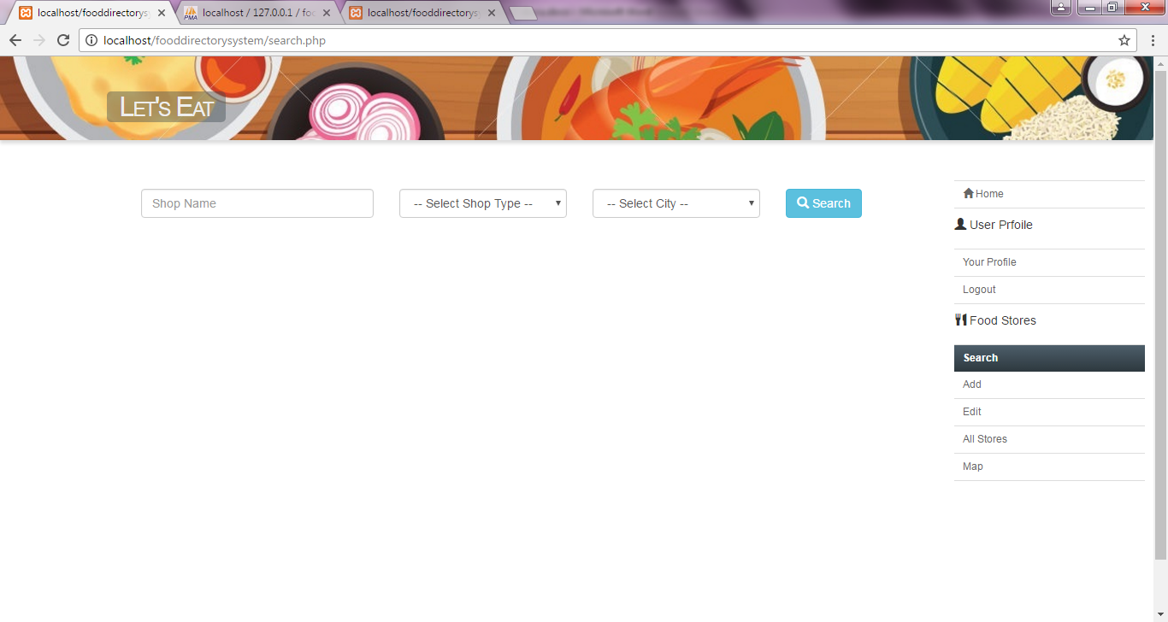

This is the searching page. In this page, the user can be able to search by name, by type and by location.

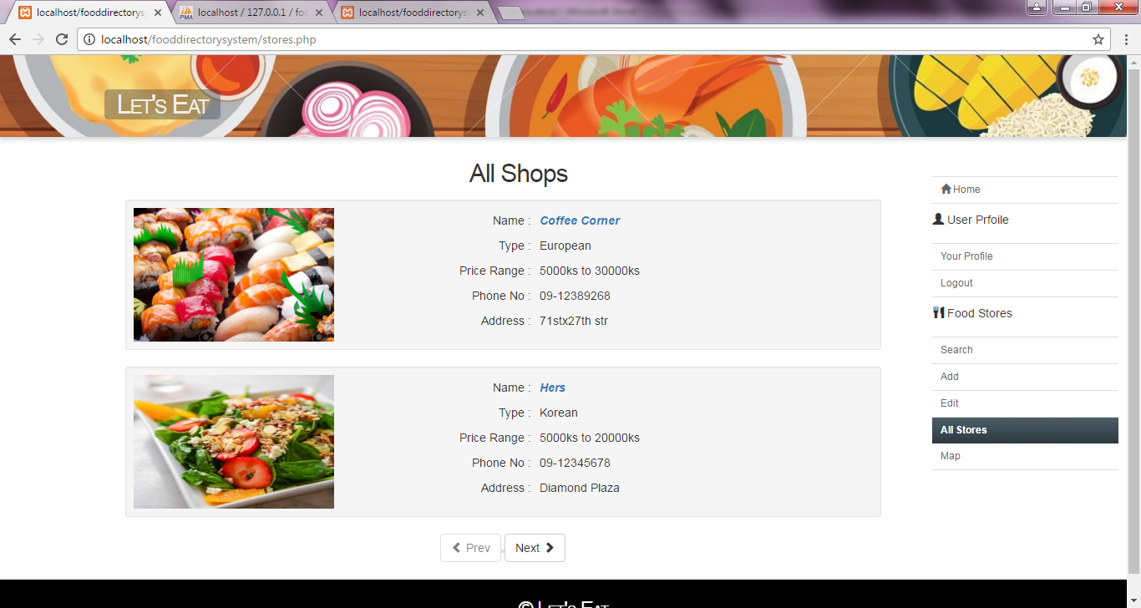

This is ‘All Shop’ page. When the user clicks on the link, the more details about that food store will appear.

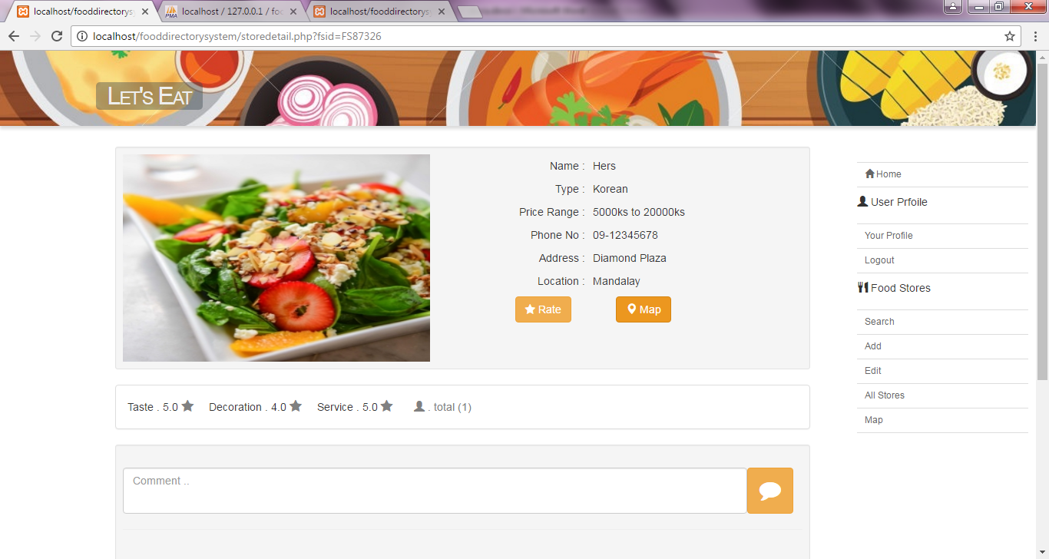

This is the food store detail page. In this page, the registered user can be able to comment and rate the food store.

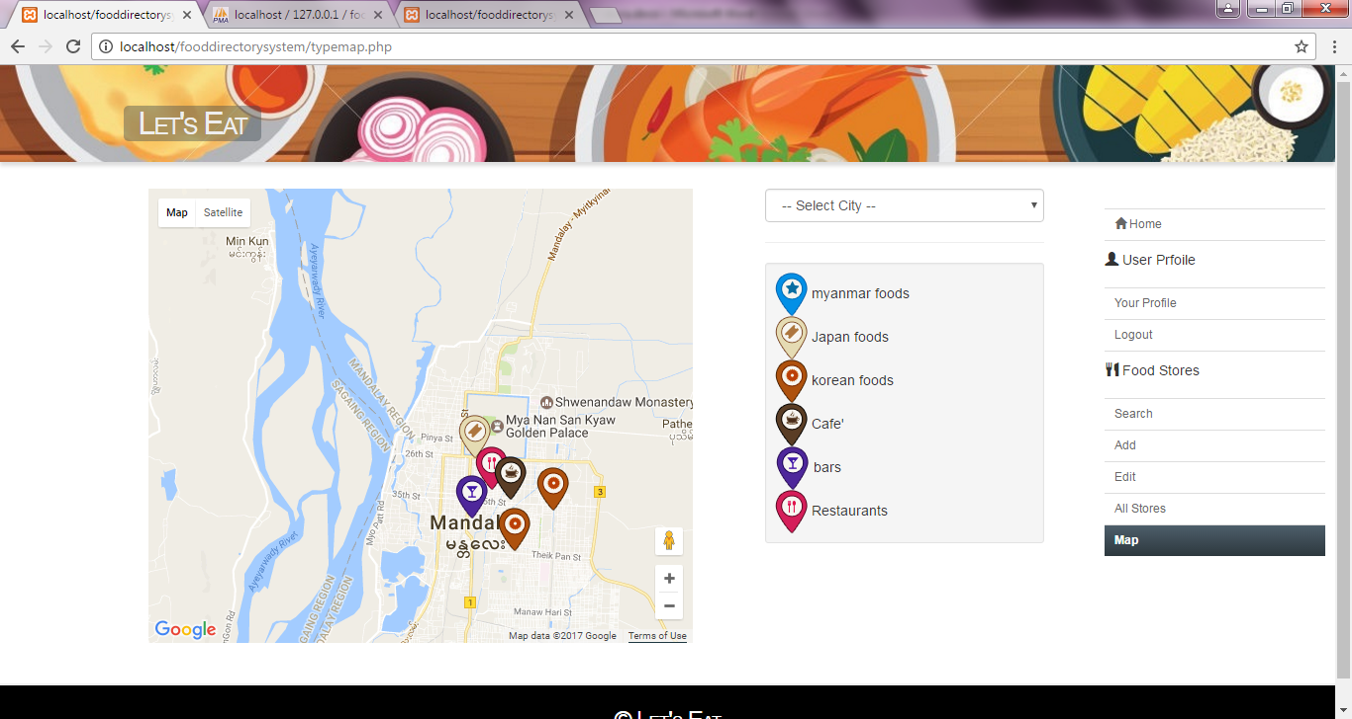

This is the map page. In this page, the map locations are categorized by map markers. The user can also choose city for map.

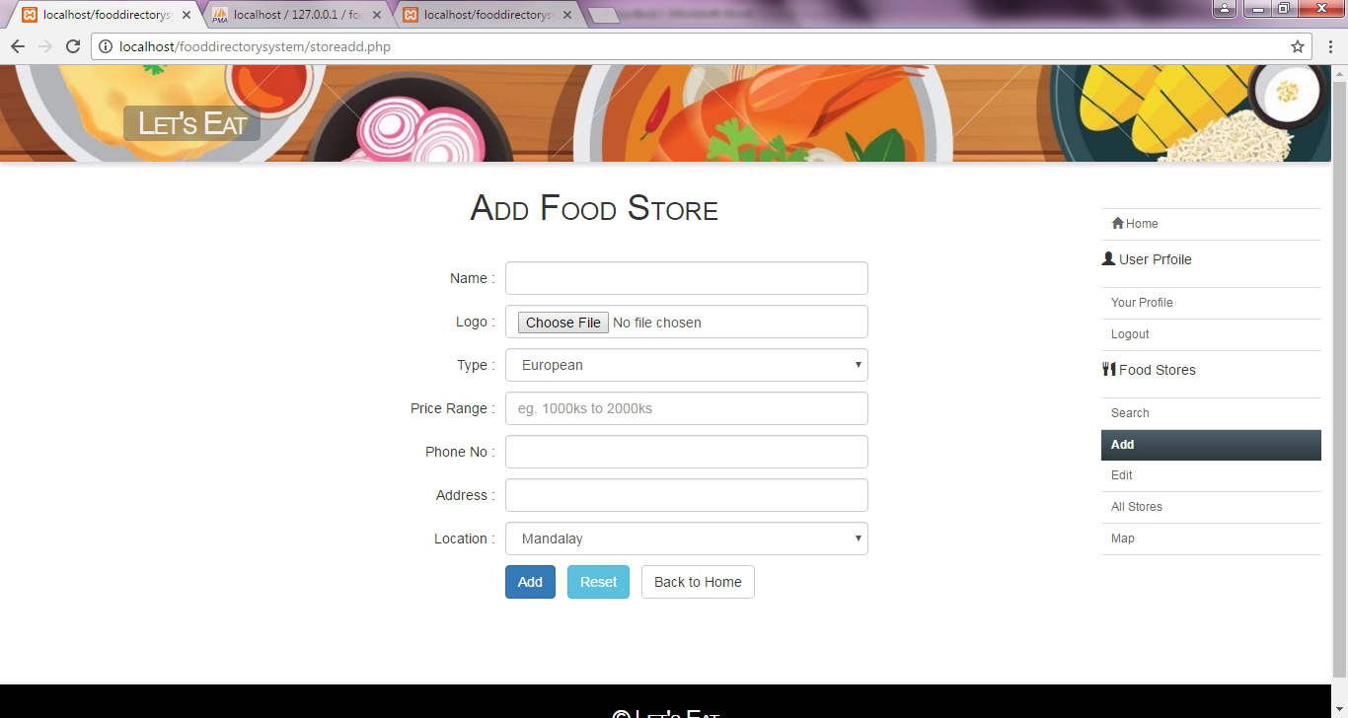

This is the add store page. From this page the user can add new stores.

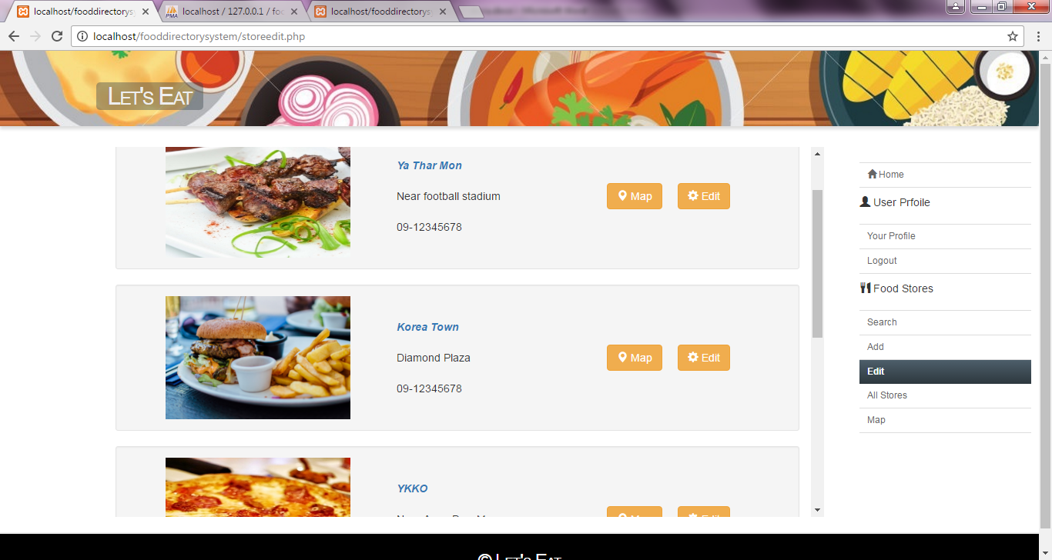

This is the edit page. From this page, the user can be able to edit his own stores.

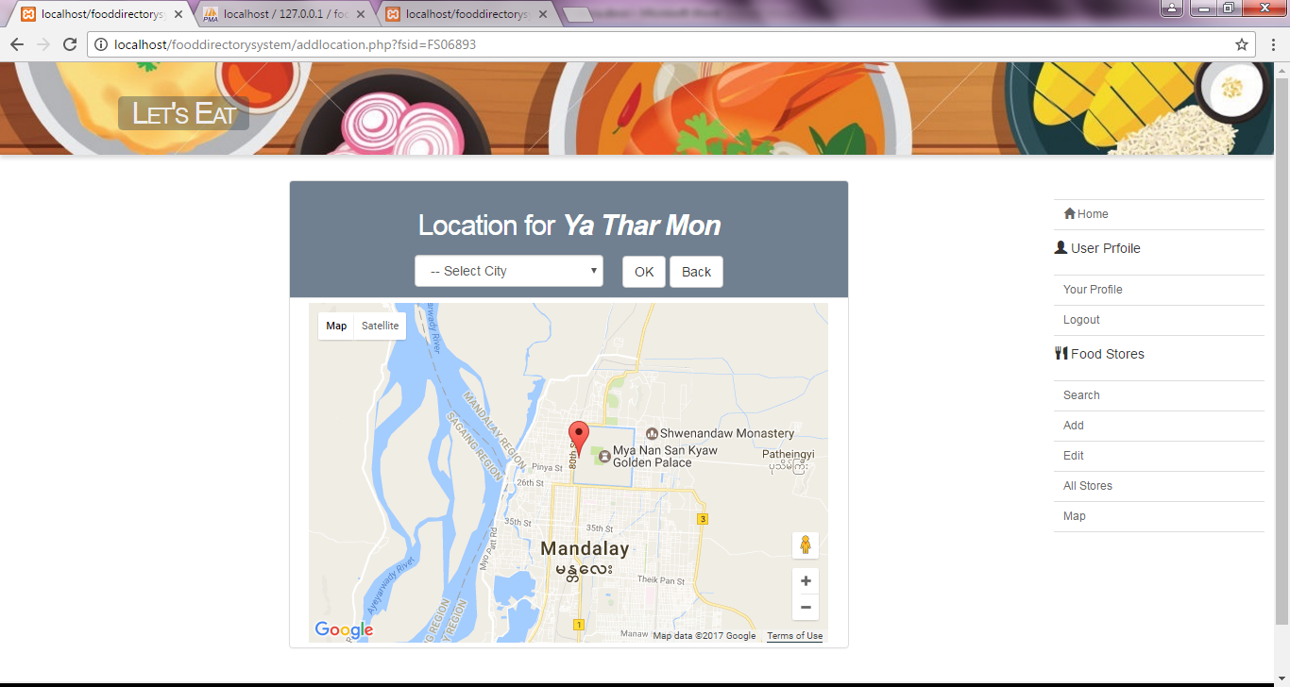

This is the ‘Add location’ page. The user can be able to add the location for each of the store he added.